**Lab Manual**

**Date of Experiment:12/02/2025**

**Date of Submission:12/02/2025**

**SVKM’S NMIMS**

**Mukesh Patel School of Technology Management & Engineering**

BTI

Subject- Robotic Process Automation

**EXPERIMENT NO. 03**

**Objective:**

This lab is designed to deepen your understanding of loops in Power Automate Desktop. The objective is to learn how to utilize loops for repetitive tasks, enabling you to create more efficient and dynamic automation flows.

**Prerequisites:**

1. Power Automate Desktop installed on your computer.

2. Basic understanding of Power Automate Desktop interface.

**Challenge Overview:**

In this experiment, you will create 3 flows

1.Create a flow that checks whether a given input is a palindrome or not. A palindrome is a sequence that reads the same forwards and backward.

2.Build a flow that generates the multiplication table for a given number.

**Important Actions:**

1. **Input Dialog:**
   * **Purpose:** Captures user input during the flow execution.
   * **Usage:** Request information, such as text or numerical values, from the user.
2. **Message Box:**
   * **Purpose:** Displays messages, alerts, or results during the flow execution.
   * **Usage:** Communicate information to the user or provide feedback on the flow's progress.
3. **Set Variable:**
   * **Purpose:** Assigns a value to a variable.
   * **Usage:** Store and manipulate data within the flow.
4. **Decision:**
   * **Purpose:** Branches the flow based on a specified condition.
   * **Usage:** Enables dynamic decision-making within the flow.
5. **Loop (e.g., For Each, While, Do Until):**
   * **Purpose:** Repeats a set of actions multiple times based on a specified condition.
   * **Usage:** Efficiently handle repetitive tasks and iterate through collections of data.
6. **Log Message:**
   * **Purpose:** Records messages in the log for debugging and troubleshooting.
   * **Usage:** Assists in diagnosing issues and understanding the flow's behavior.

**Tasks:**

1. Create a Power Automate Desktop flow that incorporates the described actions.

2. Test the flow by providing different sets of Test cases

3. Debug and troubleshoot any errors that may arise during the execution of the flow.

4. Optimize the flow for efficiency, considering factors such as readability and simplicity.

**Flow Screenshots:**

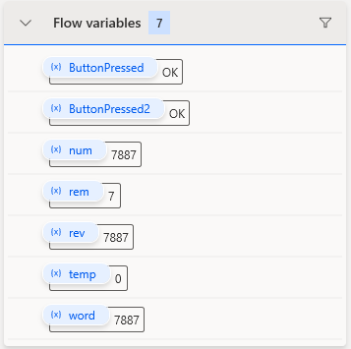

**Input Screenshots:**

**Palindrome:**

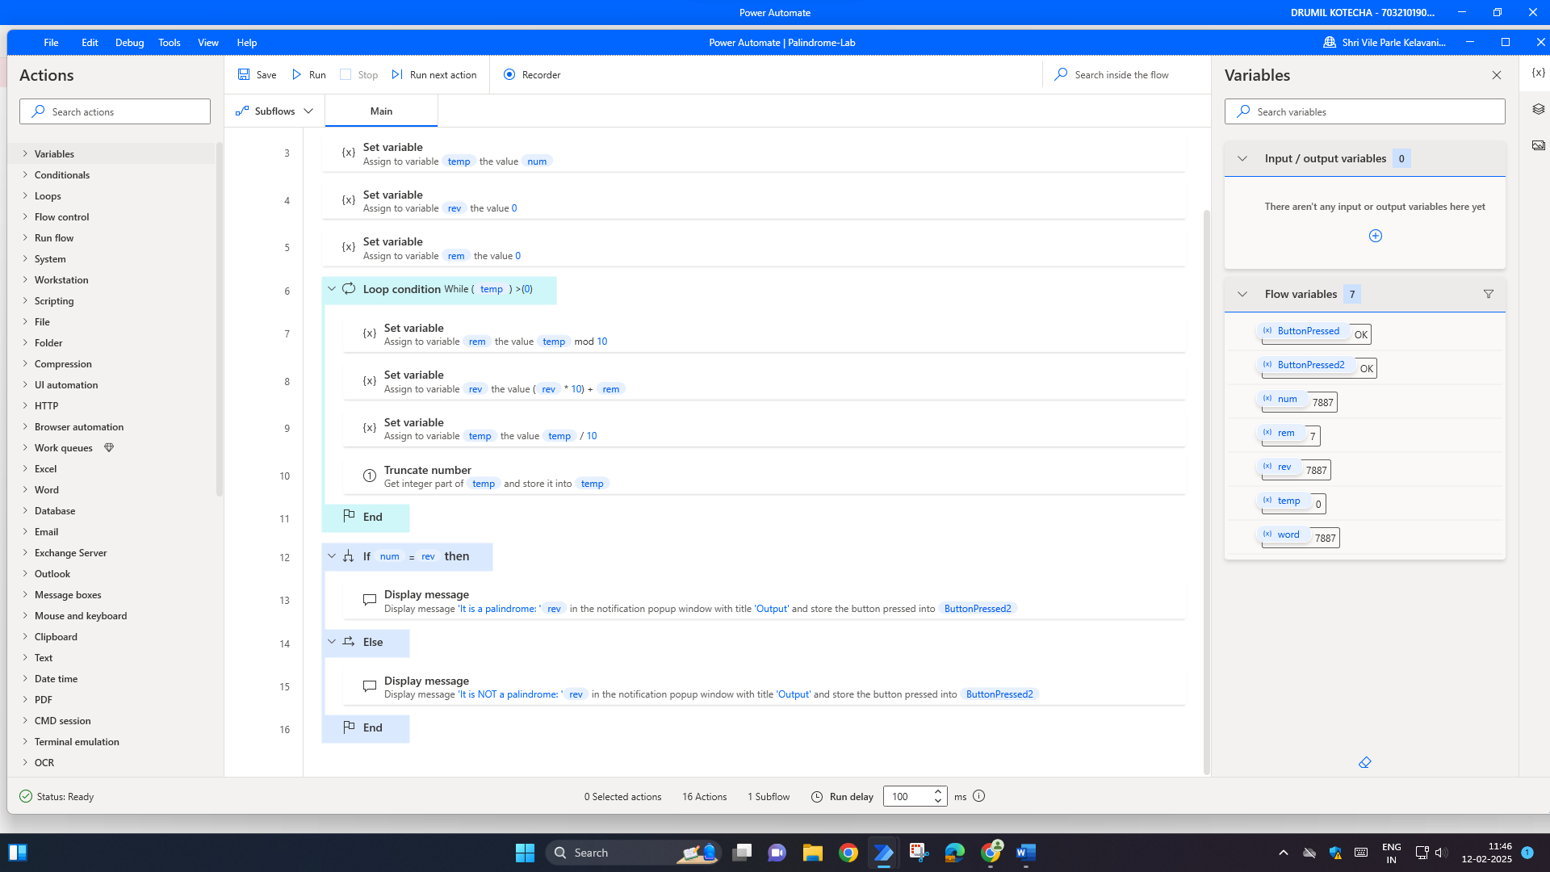

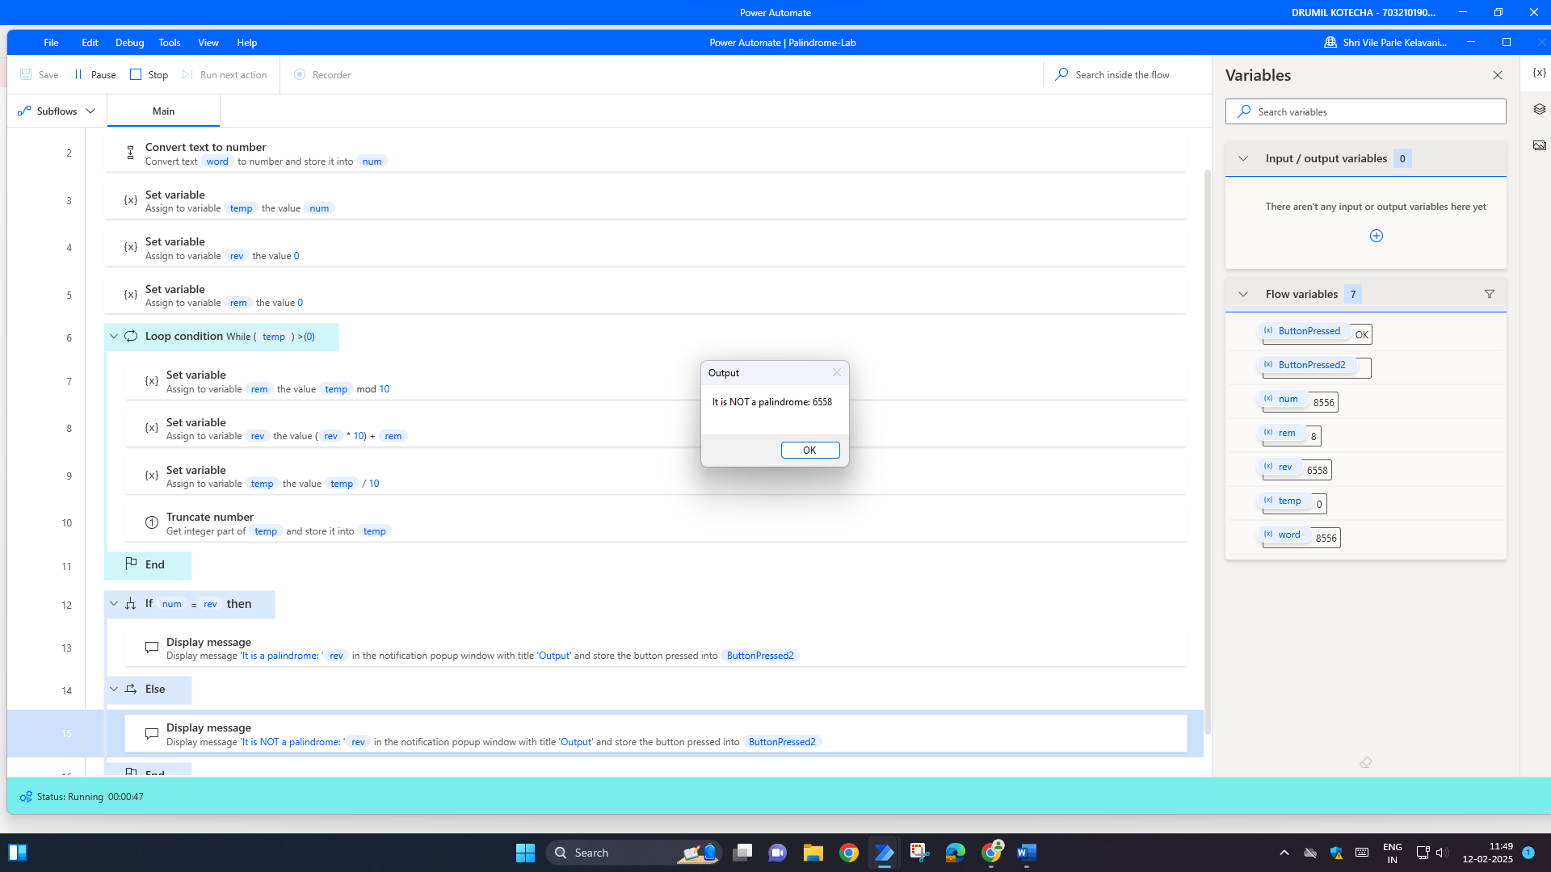

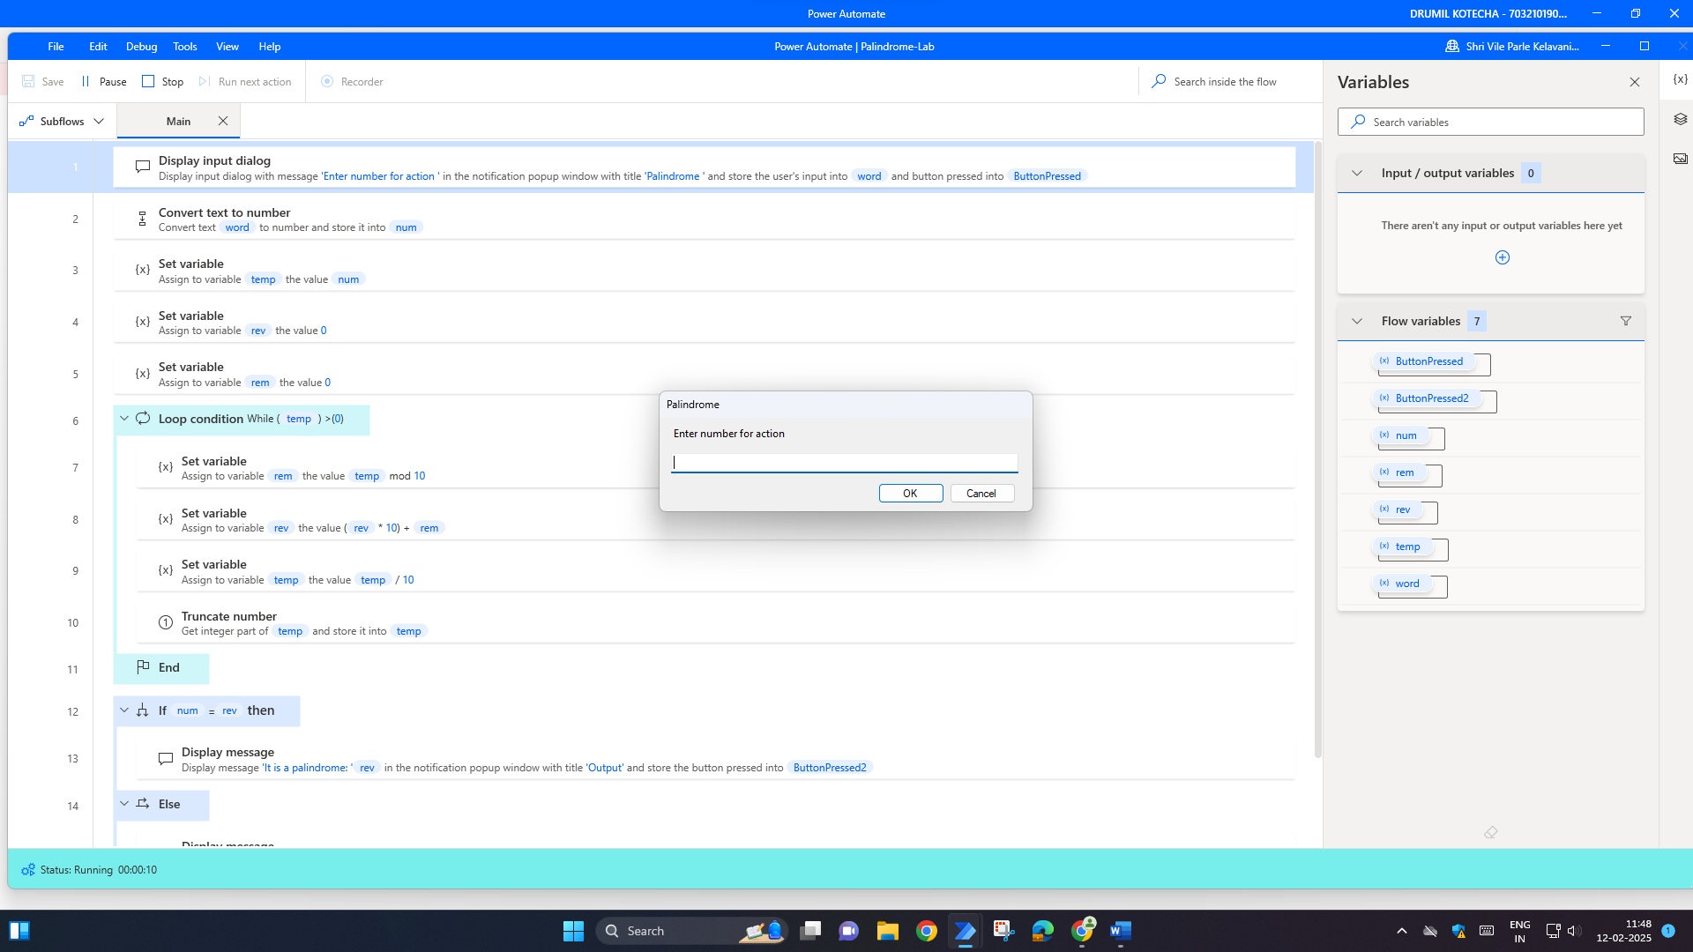

**Multiplication Table:**

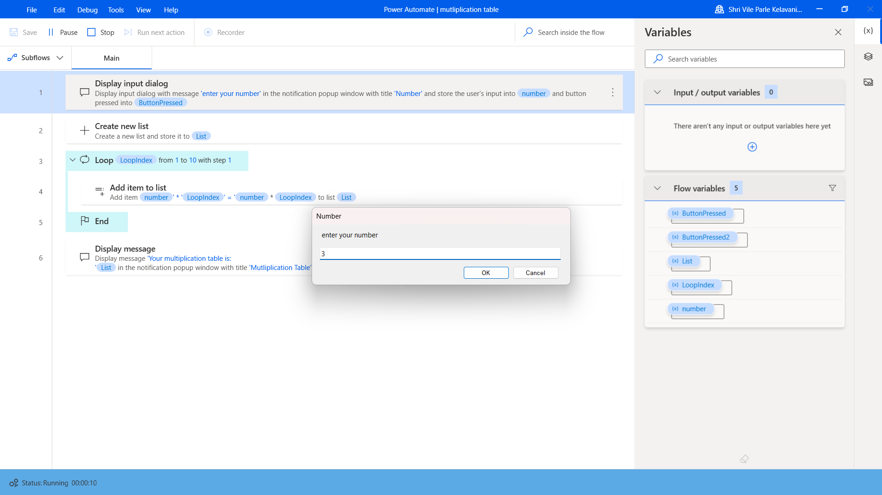

**Output Screenshot:**

**Palindrome:**

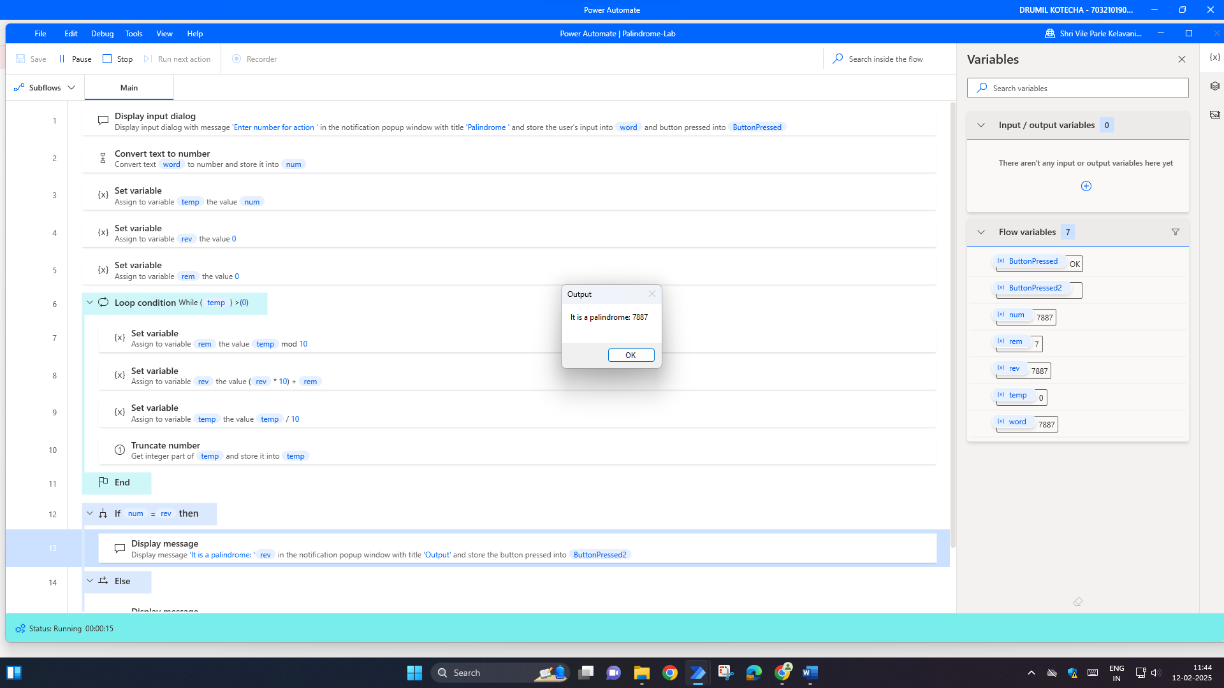

**Multiplication Table:**

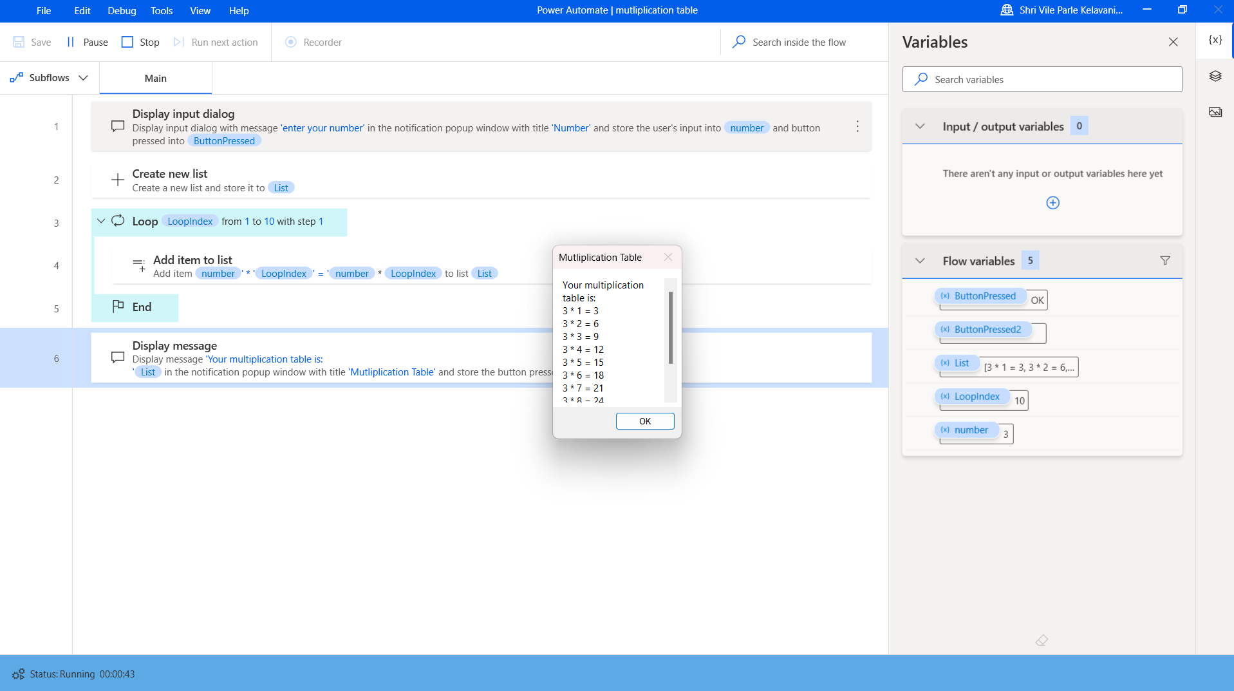

**Conclusion:**

In conclusion, the integration of Robotic Process Automation (RPA) with tasks such as generating multiplication tables and checking for palindromes offers a streamlined, efficient approach to automating repetitive processes. By automating the creation of multiplication tables, we save valuable time while ensuring consistency and accuracy in calculations. Additionally, the ability of RPA to check palindromes allows for the quick validation of string data, contributing to error-free operations. This demonstrates how RPA can simplify everyday tasks in education, data analysis, and programming, making processes faster, more reliable, and freeing up human resources for more complex tasks. The use of RPA in these areas showcases its potential to enhance productivity and optimize performance across a variety of domains.